CSSE375 Team 5 Design Document

# 1 Introduction

## 1.1 Purpose

This software design document defines the Genetic Algorithm Visualizer software design and architecture. Outlined in the following sections is an attempt to record the progression of the systems design as the refactoring team looks to improve said design.

## 1.2 Overview

This document will provide a milestone-by-milestone update of the current design of the system as well design considerations for future milestones.

# 2 Initial Design before Refactoring

## 2.1 Initial Design

## 2.2 Initial Design Analysis

Although there is some structure present in the initial design, having been created in CSSE220, the system suffers from a strong dependency on the Chromosome class. Additionally, this design fails to encapsulate what varies specifically the current running settings.

# 3 Milestone 2 Design

## 3.1 Design Image

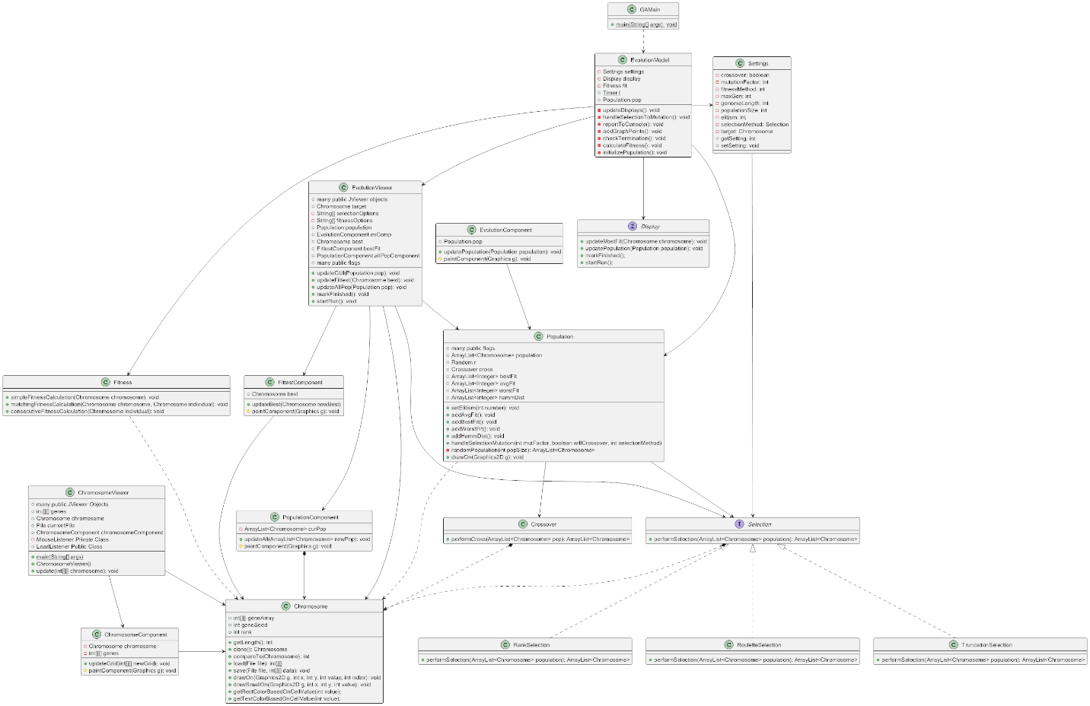

## 3.2 Analysis

Major changes include the deletion of the mutation class, the introduction of the Selection strategy, and the display interface to provide a contract for future GUI implementations to satisfy.

## 3.3 Feature Reflection

The main feature of this milestone was to provide a GUI that was independent of the actual algorithm. This was accomplished using the settings class and display class.

## 3.4 Future Considerations

In milestone 3 we plan on expanding the selection, fitness, and crossover functionality. The current fitness and crossover functionality will be refactored into strategy pattern designs similar to the current design of selection.